**1920s French Two-Tiered Sunburst Mirror**

**Price: $3495**

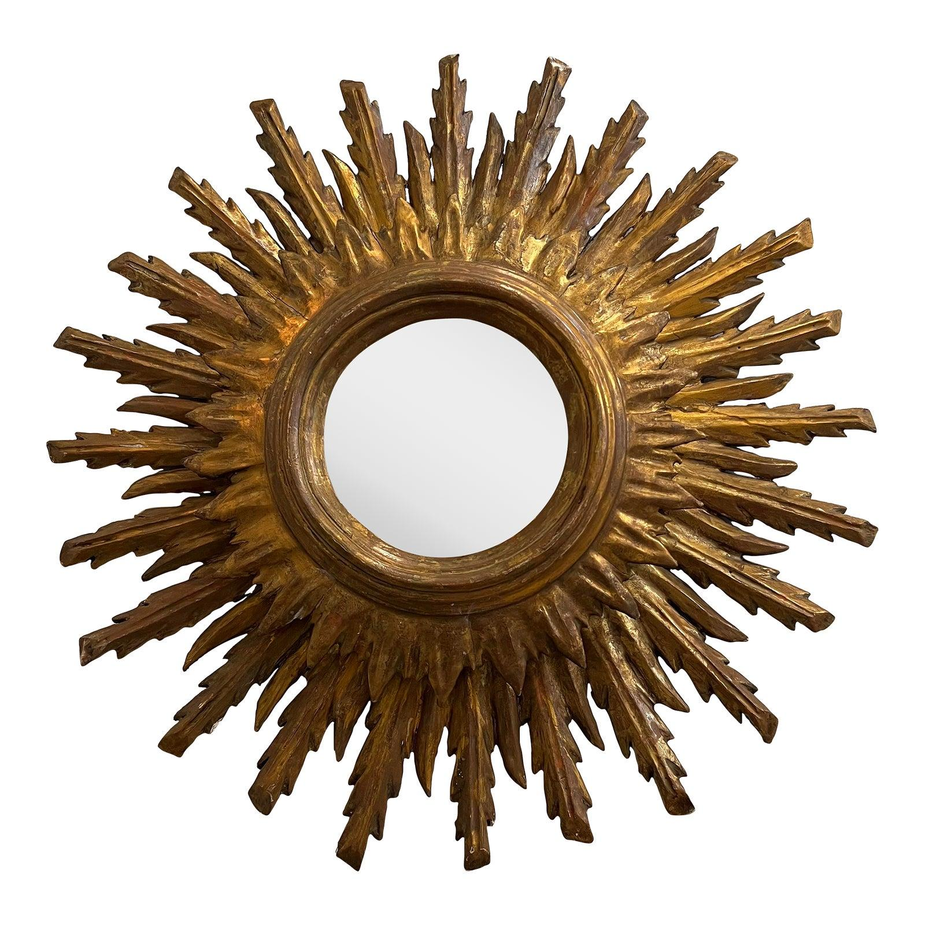

* CATEGORIES

Bedroom Mirrors

* MATERIALS

LED Mirrors

* SHAPE

Circle

* BRAND

Citybuilding